Pyspark_Assignment_Task2_Crime_data_Analysis_Anup_Patil  
  
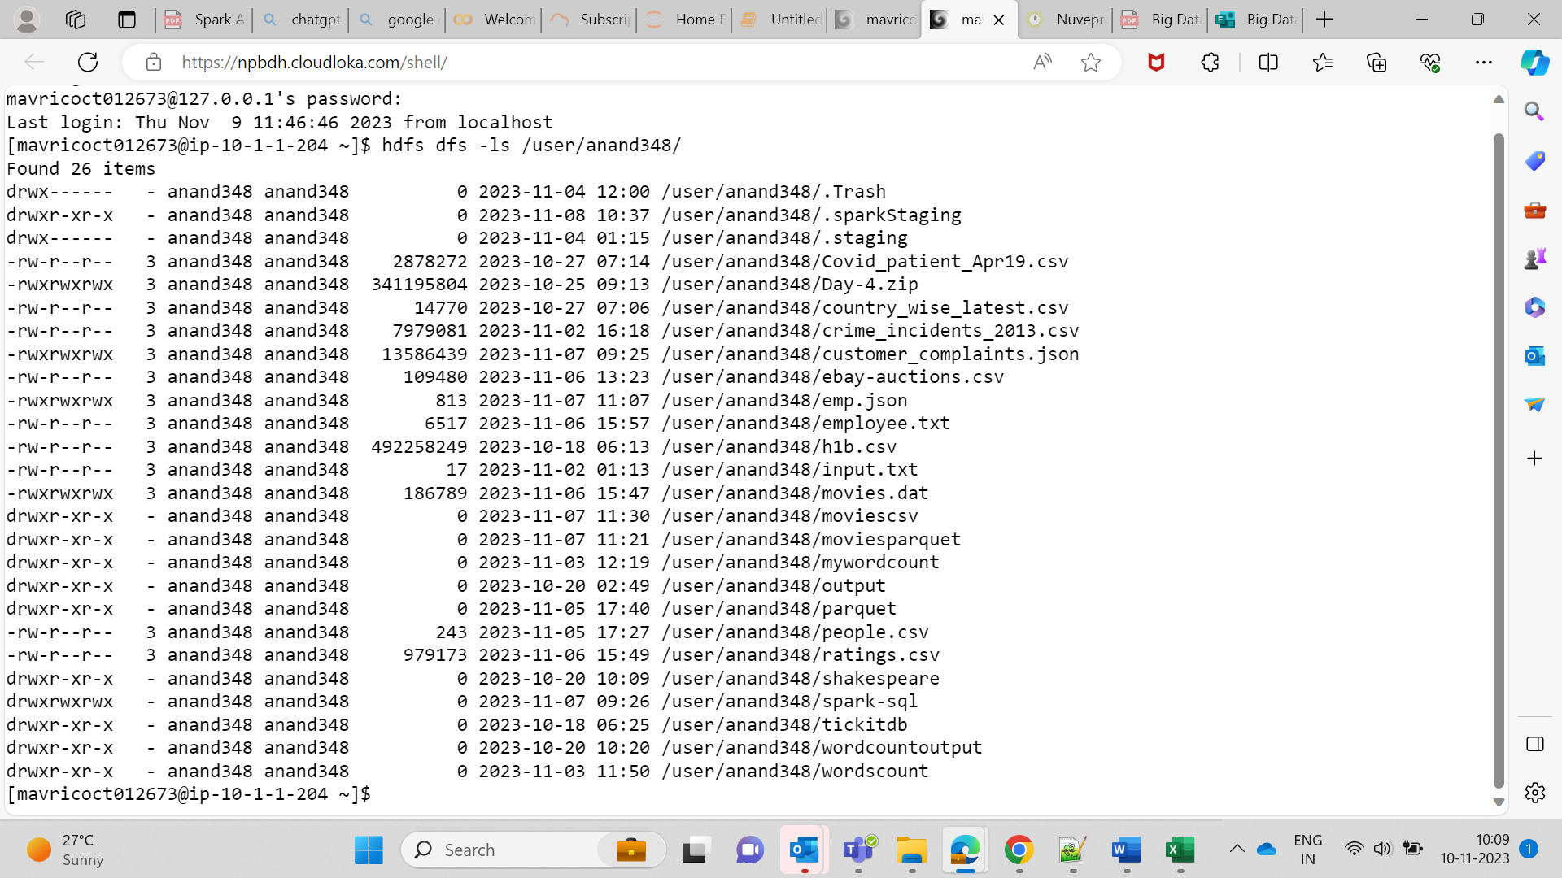  
  
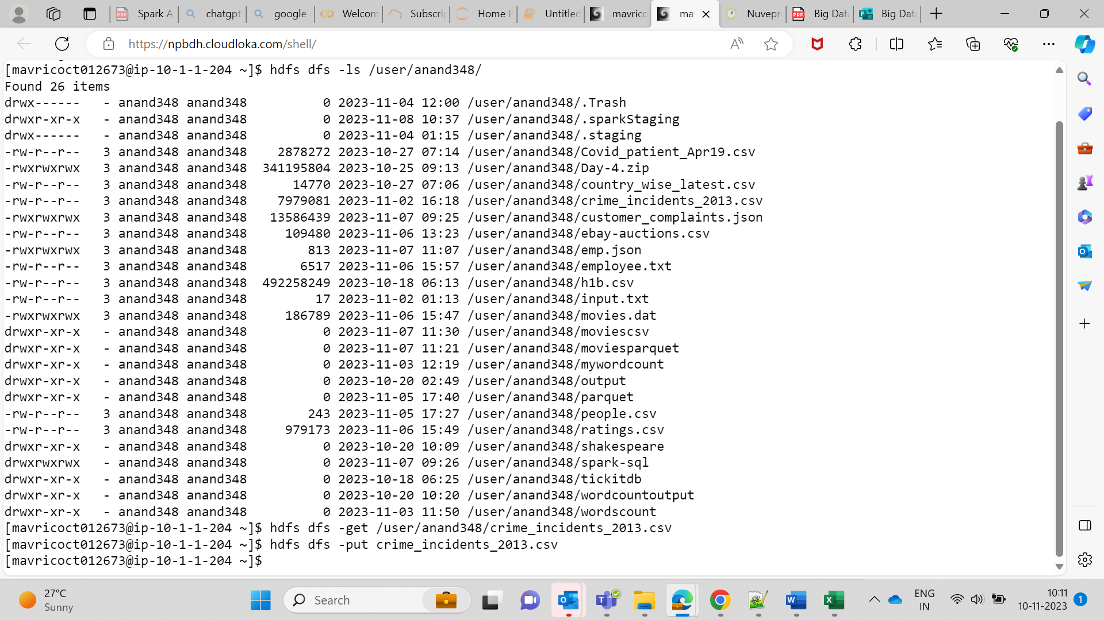  
  
**Q1. How many offenses were there in 2013?**Q2.How many crimes were committed in each offense?  
  
**Q3. How many different methods were used (And their count) in offense “Homicide”**  
  
  
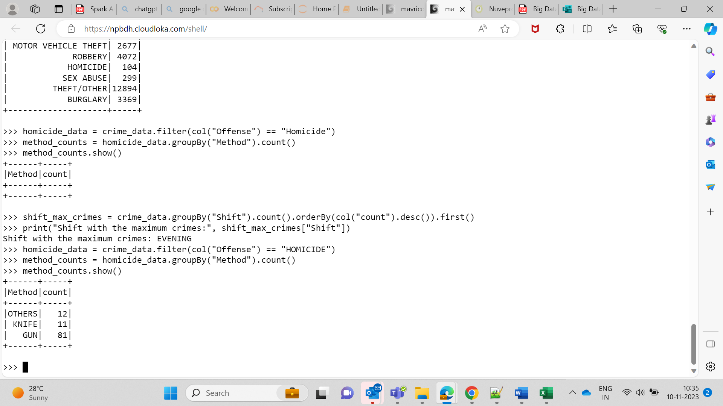  
  
  
**Q4. Which shift had the maximum crimes?**  
  
